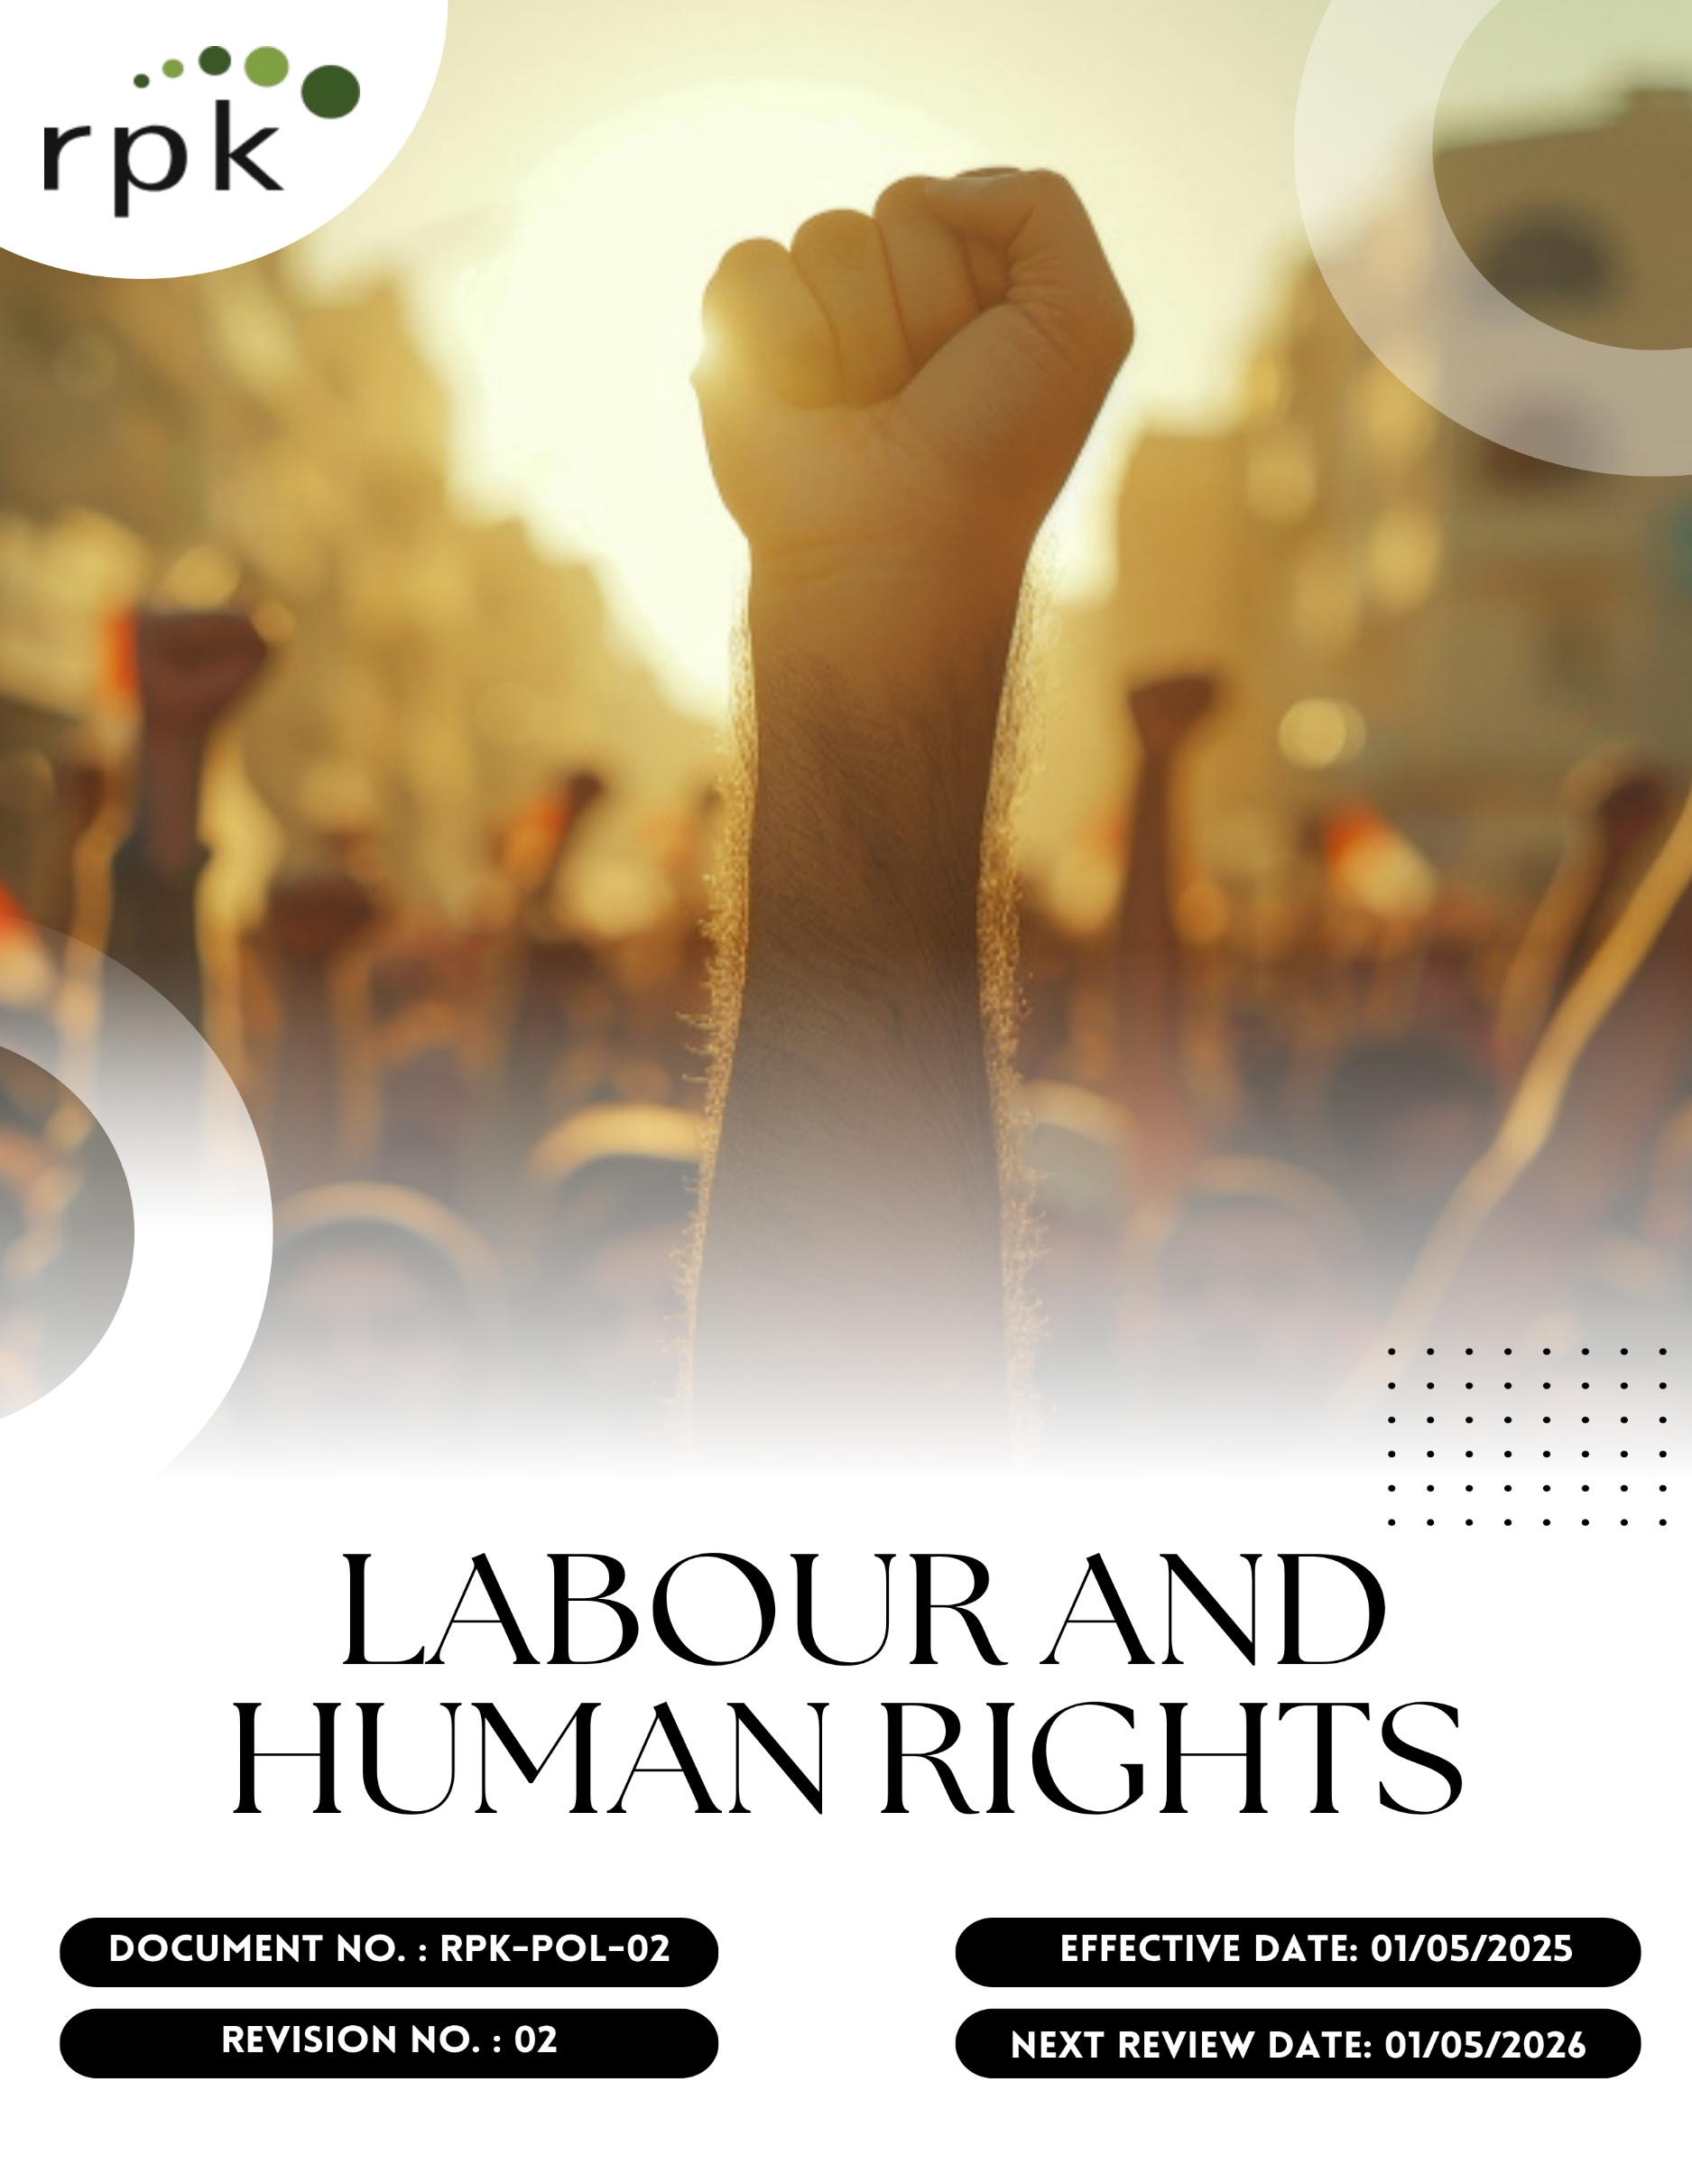

Contents

Preface 3
Policy Declaration 3
Scope 3
Key Focus Areas 4
Qualitative Objectives 4
Quantitative Targets 6
Alignment with the United Nations Sustainable Development Goals (SDGs) 8
Responsibilities 8
Monitoring, Reporting, and Transparency 8
Review Mechanism and Continuous Improvement 9
Employee Acknowledgment Form 10

Preface
At RPK India Pvt. Ltd., we believe that the strength of our business lies not only in engineering excellence and precision manufacturing, but equally in the dignity, safety, and well-being of our workforce. We recognize every individual’s right to fair treatment, safe working conditions, non-discrimination, and opportunities for personal and professional growth. This policy is designed to ensure that all of our employees, contractors, and supply chain partners are treated with respect and fairness, that their health, safety, and rights are protected, and that we comply with all applicable local and international labor laws and norms. We aim not just for legal compliance, but to foster an inclusive and equitable work environment where human rights are fundamental to everything we do.

Policy Declaration
RPK India Pvt. Ltd. is committed to respecting and protecting labor and human rights, ensuring a workplace free from discrimination, harassment, forced, or child labor. We uphold fair wages, safe working conditions, employee well-being, equal opportunities, and transparent performance evaluations, while providing grievance and whistleblower channels to ensure accountability.

Scope
This policy applies to all employees, contractors, and partners of below given site of RPK India Pvt. Ltd. It covers employment practices, health and safety, training, and grievance mechanisms, and extends to our supply chain, ensuring partners uphold similar labor rights and ethical standards across all departments and functions..

Site | Address
RPK India Pvt. Ltd. | Plot No. 1A, IndoGlobal Industrial Park Gat No. 1122(P), 1129(P), 1140, 1295, 1296 Shriwal, Maharashtra 412801, India

Key Focus Areas
- Employees’ Health and Safety – Ensure a safe and healthy workplace through training and risk management.
- Working Conditions – Provide working hours in accordance with regulations and ensure respectful and fair treatment for all employees.
- Social Dialogue – Promote open communication and employee engagement.
- Career Management and Training – Support skill development and equal opportunities for career growth.
- Child Labor, Forced Labor, and Human Trafficking – Prohibit all forms of child labor, forced work, and trafficking in our operations and supply chain.
- Discrimination and Harassment – Enforce zero-tolerance for unfair treatment, foster inclusion.
- External Stakeholder Human Rights – Respect and protect the rights of communities, suppliers, customers, and other stakeholders.
- Diversity, Equity, and Inclusion – Promote equal opportunities and a diverse workforce.
- Work-Life Balance – Support flexible work arrangements and employee well-being.

Qualitative Objectives
- Employee Health and Safety
- Foster a culture of safety-first mindset across all operations.
- Regularly enhance health and safety protocols to proactively address workplace risks and promote employee well-being and hence maintain zero absenteeism due to work-related injuries.

- Working Conditions
- Promote a workplace culture that prioritizes ethical practices, psychological safety, and employee satisfaction.
- Ensure continuous improvement in workplace facilities and practices.
- Ensure working conditions compliance with global labor standards and local regulations.

- Social Dialogue
- Foster open dialogue through structured communication channels and inclusive participation in workplace decision-making.
- Conduct annual labor-management meetings with documented minutes and action points.
- Strengthen employee representation and participation in workplace decisions.

- Career Management and Training
- Promote continuous learning through structured training, career planning, and periodic performance reviews & foster a culture of lifelong learning and innovation.

- Child Labor, Forced Labor, and Human Trafficking
- Enforce and maintain zero tolerance for child, bonded, or forced labor across all operations and suppliers.
- Strengthen supplier and partner due diligence on labor practices.
- Ensure strict monitoring and remediation mechanisms are in place.

- Discrimination and Harassment
- Ensure an inclusive, respectful workplace free of bias, discrimination, and harassment and hence maintain zero cases of harassment or discrimination.
- Strengthen grievance redressal mechanisms for fair resolution.

- External Stakeholder Human Rights
- Integrate human rights due diligence into business operations and key relationships to mitigate rights-related risks.
- Engage stakeholders to address potential or actual human rights impacts.
- Respect and safeguard the rights of local communities near operations.
- Diversity, Equity, and Inclusion (DEI)
- Create opportunities for underrepresented groups in the workforce.
- Promote equal access to leadership and career advancement.
- Embed diversity and inclusivity into recruitment and retention practices.

- Work-Life Balance
- Encourage flexible and supportive work arrangements.
- Promote employee wellness through stress management and support programs.
- Ensure workloads are managed fairly to maintain productivity and well-being.

Quantitative Targets
All targets outlined in the Labor and Human Rights Policy are based on the baseline data from year 2022. Progress will be evaluated annually, with the objective of achieving key milestones by target year 2030, covering key areas such as employee well-being, ethical labor practices, inclusivity, fair compensation, and responsible partnerships.

- Employee Health and Safety
- Ensure 100% accessibility to health and safety information and emergency protocols for all employees.
- To increase safety inspections by 5% till year 2030 to proactively identify risks.
- Conduct 100% mandatory safety training for all employees yearly.
- Maintain zero fatalities across all operational sites.

- Working Conditions
- Conduct employee satisfaction surveys annually on working conditions, aiming for 95% positive responses by year 2030.
- Ensure implementation of a formal channel for 100% employees to discuss working conditions with management by year 2030.
- Provide healthcare benefits to 100% employees by year 2030.

- Social Dialogue
- Ensure 100% of employees have access to formal platforms to express concerns and feedback.
- Achieve 70% response rate in employee engagement activities by year 2030.
- Resolve 95% of reported concerns within 30 days.

- Career Management and Training
- Conduct annual performance reviews and ensure career development plans are in place for 100% of eligible employees.
- Allocate 20% of the manpower budget to employee development programs by year 2030.
- Increase internal promotions by 10% by year 2030 by implementing structured career pathways and targeted upskilling programs.

- Child Labor, Forced Labor, and Human Trafficking
- Conduct background checks for 100% of suppliers by year 2030.
- Train 100% procurement and recruitment staff on labor compliance policies annually.
- Maintain zero confirmed cases of child or forced labor till year 2030.

- Discrimination and Harassment
- Conduct 2 workplace climate surveys on discrimination and harassment till year 2030 through survey forms filled by 100% employees.
- Provide mandatory anti-harassment and DEI training to 100% employees yearly.

- External Stakeholder Human Rights
- Ensure that 100% of supplier contracts include and comply with human rights clauses by the year 2030.
- Train 100% of procurement teams on human rights policies annually.
- Maintain zero reported human rights violations across operations.
- Conduct human rights impact assessments across operations annually.

- Diversity, Equity, and Inclusion (DEI)
- Increase female workforce representation by 10% by year 2030.
- Launch 2 DEI awareness programs till year 2030.

- Work-Life Balance
- Offer flexible work arrangements for 100% eligible employees.
- Maintain absenteeism rate below 3% annually.

Alignment with the United Nations Sustainable Development Goals (SDGs)
The sustainability objectives and performance targets align with the following Sustainable Development Goals (SDGs):
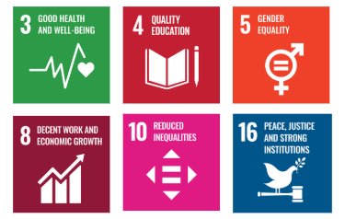

Responsibilities
- Senior Management: Ensure implementation of fair labor policies and allocate resources for employee well-being.
- Human Resources Team: Monitor labor conditions, oversee training programs, and address grievances.
- Operations & Manufacturing: Implement workplace safety and ethical labor standards.
- Supply Chain & Procurement: Ensure responsible sourcing and compliance with supplier labor policies.
- Employees: Adhere to workplace policies, report concerns, and participate in training initiatives.
- External Stakeholders: Support labor and human rights initiatives through responsible business practices.

Monitoring, Reporting, and Transparency
RPK India Pvt. Ltd. is committed to regularly monitoring its labor and human rights performance across key focus areas such as employee health and safety, working conditions, social dialogue, career management and training, prevention of child and forced labor, non-discrimination and harassment, and respect for external stakeholder human rights. Key Performance Indicators (KPIs) are established for each area and tracked through internal monitoring systems to evaluate progress against defined commitments. These KPIs are reviewed on a quarterly basis, and findings are consolidated into performance reports for senior management to guide strategic decision-making. Annual assessments capture achievements, identify gaps, and recommend corrective measures, while relevant outcomes are shared with stakeholders to promote transparency and accountability. All monitoring and reporting practices adhere to applicable labor laws, international conventions, and industry best practices, ensuring reliability, accuracy, and credibility in disclosures.

Review Mechanism and Continuous Improvement
This policy will be reviewed annually by the Human Resources Manager to assess its effectiveness and alignment with evolving labor standards, human rights commitments, and applicable legal requirements. Feedback from audits, employee input, and stakeholder consultations will be incorporated into updates. Necessary revisions will be made to strengthen labor and human rights practices and drive continuous improvement. Any significant changes or updates will be communicated to all employees and relevant stakeholders to ensure effective implementation.

Effective Date | : 01.05.2025
Next Review Date | : 01.05.2026
Revision No. | : 01

Approved By:

Employee Acknowledgment Form
I hereby acknowledge that I have read and understood the Labor and Human Rights Policy of RPK India Pvt. Ltd. I am aware of the company’s commitment to upholding fair and ethical labor practices, including the prevention of child labor, forced labor, discrimination, harassment, and ensuring safe and healthy working conditions. I understand that respecting human rights is a collective responsibility, and I pledge to uphold these principles in my daily work by treating all colleagues, contractors, and stakeholders with dignity, fairness, and respect. I will actively support RPK India’s efforts to maintain a safe, inclusive, and equitable workplace and contribute to fostering a positive organizational culture.
By signing this document, I confirm my commitment to the labor and human rights values of RPK India Pvt. Ltd. and agree to participate in training sessions, awareness programs, and continuous improvement initiatives as required.

Employee Name | : _________________________
Employee ID | : _________________________
Department | : _________________________
Signature | : _________________________

